**LAB 07 : Supervised learning: Linear Regression and Naïve Bayes using SciKit.**

**LAB TASKS:**

**Perform both algorithms with any other dataset and try to analyze the outputs by changing the parameters.**

**NAIVE_BAYES**

| **Data.columns**  **Index(['Pregnancies', 'Glucose', 'BloodPressure', 'SkinThickness', 'Insulin',**  **'BMI', 'DiabetesPedigreeFunction', 'Age', 'Outcome'],**  **dtype='object')** |
| --- |

| **from sklearn.model_selection import train_test_split**  **x= data.drop(['Outcome'],axis =1)**  **y=data['Outcome']**  **xTrain, xTest, yTrain, yTest = train_test_split(x, y, test_size = 0.2, random_state = 0)** |
| --- |

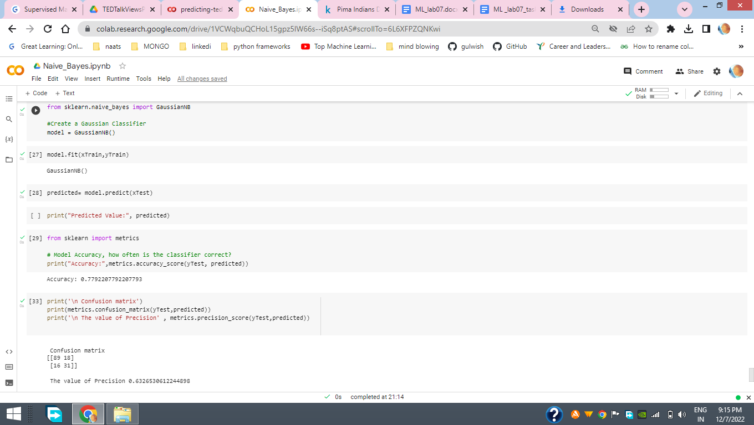

***LINEAR Regression***

| ***x=data_df.drop(['Class'], axis = 1)#drop the target variable***  ***y=data_df['Class']***  ***xtrain, xtest, ytrain, ytest = train_test_split(x, y, test_size = 0.2, random_state = 42)*** |
| --- |

| ***logisticreg = LogisticRegression()***  ***logisticreg.fit(xtrain, ytrain)*** |
| --- |

| ***y_pred = logisticreg.predict(xtest)***  ***accuracy= logisticreg.score(xtest,ytest)***  ***print('Accuracy score of the Logistic regression model: ', accuracy*100,'%')***  ***Accuracy score of the Logistic regression model: 99.85955549313577 %*** |
| --- |

| ***cm = metrics.confusion_matrix(ytest, y_pred)***  ***print(cm)***  ***[[56829 35]***  ***[ 45 53]]*** |
| --- |